**International University of Sarajevo**

Computer science and engineering

Software engineering

Sarajevo, 19.4.2017.

**SPECIFICATION DOCUMENT**

# KoomDriving

VOL 1.0

**Students**:   
Adem Dinarević

Ahmed Aletić

Aziz Boudela

**CONTENT**

1. Objectives
2. System decomposition/design
   1. Class diagrams
3. Use cases
4. Sequence diagrams
5. User interface
6. References
7. Extra
8. **Objectives**

This is a specification-design document for the Windows form application called **koomDriving**. This document contains the system decomposition and design, where class diagrams are included, also detailed use case scenarios are included with different attributes. In the end sequence diagrams and the whole user interface is included. More details about the following features can be find in this document. Regarding the functional and non-functional requirements, refer to the Requirements document.

**2. System decomposition**

* 1. Class diagrams

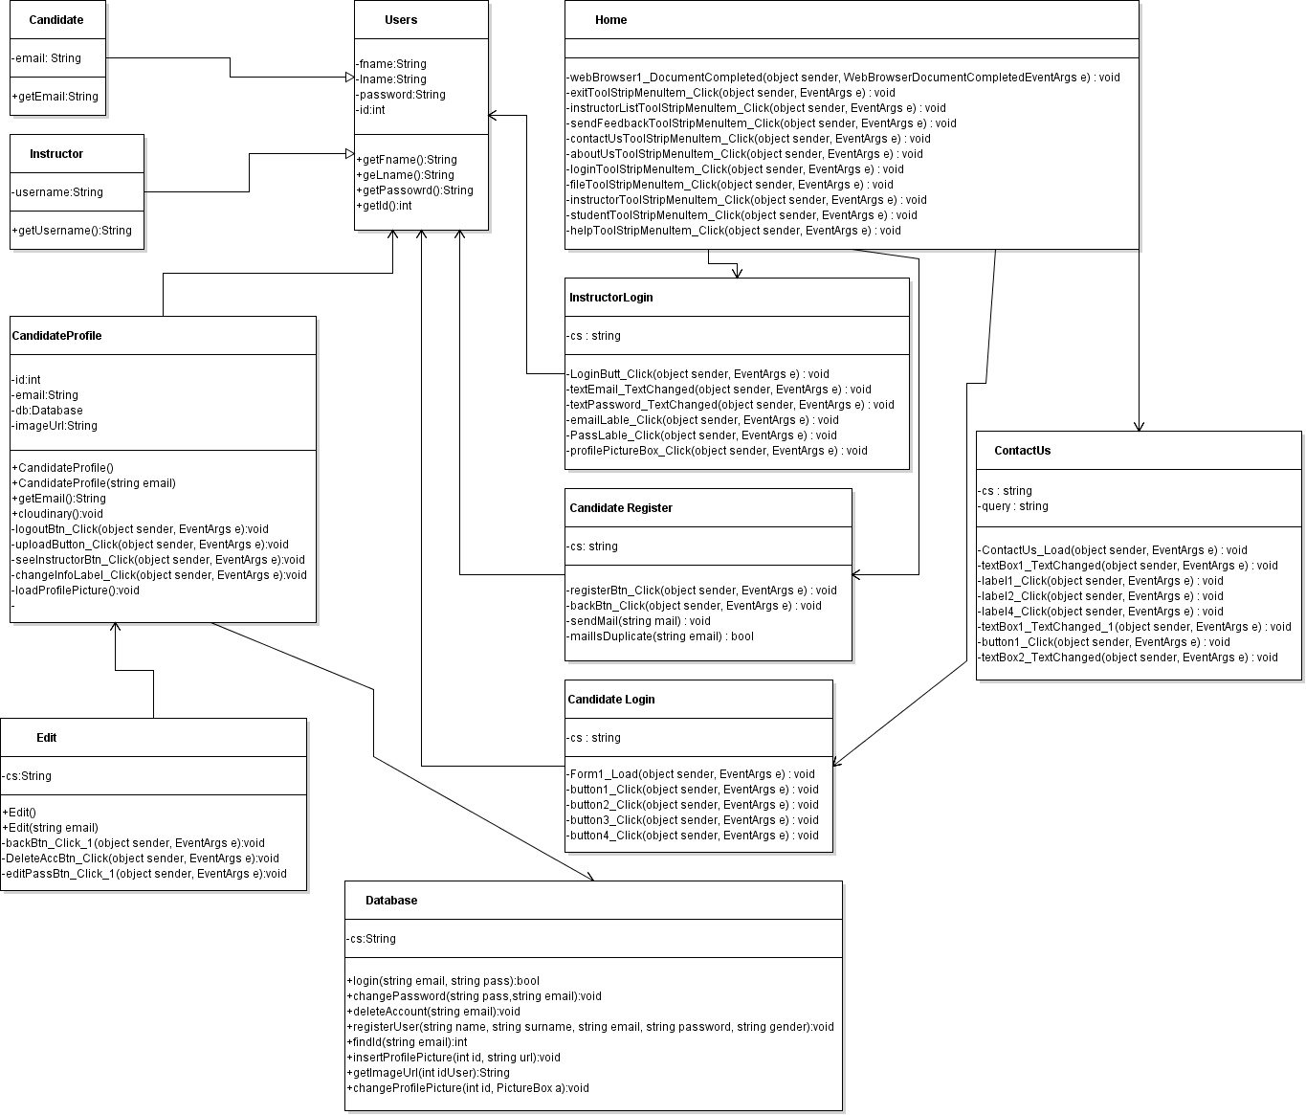

1. **Use cases**

**Use case name:** Candidate Login

**Priority**: Essential

**Direct actor(s):** Candidate

**Pre-condition:** Login form opened and candidate has registered with valid email

**Post**-**condition**: Student profile form opened and user logged

**Scenario for the use case:**

1. **Initial assumption**: The candidate has registered and his email and password are stored in the database
2. **Normal**: the candidate enters his email and password and logs in to the candidate profile which is in another form
3. **What can go wrong?** – the candidate did not register or entered his info correctly
4. **Other** **activities** - none
5. **System** **state** **on** **completion**. Login form is closed and Candidate profile form is opened

**Use case name:** Edit candidate profile

**Priority**: Normal

**Direct actor(s):** Candidate

**Pre-condition:** User logged in

**Post**-**condition**: changed data in database for candidate

**Scenario for the use case:**

1. **Initial assumption**: The candidate has successfully logged in to his profile
2. **Normal**: Candidate clicks edit button on Candidate profile which opens the Edit form and he has options to change password, change picture or delete account
3. **What can go wrong?** – the user is not logged in
4. **Other** **activities** - none
5. **System** **state** **on** **completion**. Edit page is closed and redirected to his profile again

**Use case name:** Upload photo

**Priority**: Normal

**Direct actor(s):** Candidate

**Pre-condition:** User logged in

**Post**-**condition**: added new data in database for candidate and to an image cloud service

**Scenario for the use case:**

1. **Initial assumption**: The candidate has successfully logged in to his profile
2. **Normal**: If candidate does not have a profile picture, an upload button is on initial screen, user chooses his photo, photo is stored in cloudinary.com image cloud service and retrieved to an picture box in candidate profile form
3. **What can go wrong?** – user uploads an image which is not supported
4. **Other** **activities** - none
5. **System** **state** **on** **completion**. Picture box is filled with the chosen picture

**Use case name:** Candidate Register

**Priority**: Essential

**Direct actor(s):** Candidate

**Pre-condition:** Enter to home page

**Post**-**condition**: Student profile after entered info is registered

**Scenario for the use case:**

1. **Initial assumption**: The candidate entered home page and clicked register
2. **Normal**: the candidate enters his required information and registers to the candidate register
3. **What can go wrong?** – the candidate did not open home page and clicked to register
4. **Other** **activities** - none
5. **System** **state** **on** **completion.** Registration data stored in data base.

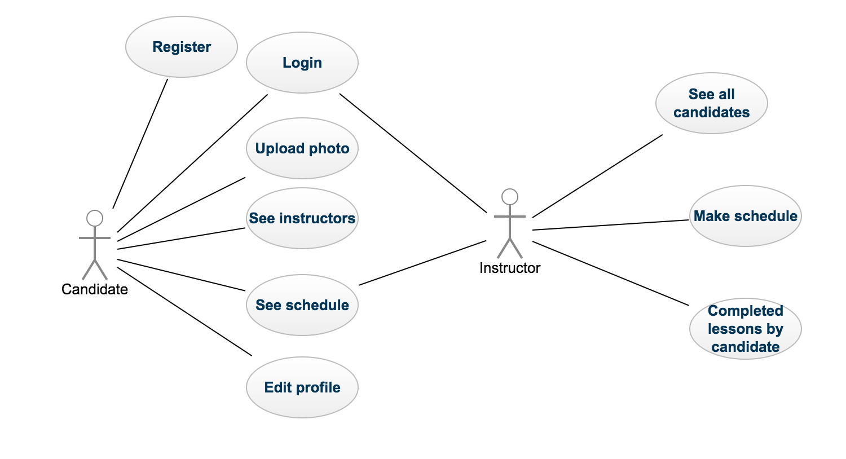

1. **Sequence diagrams**

**Login diagram**

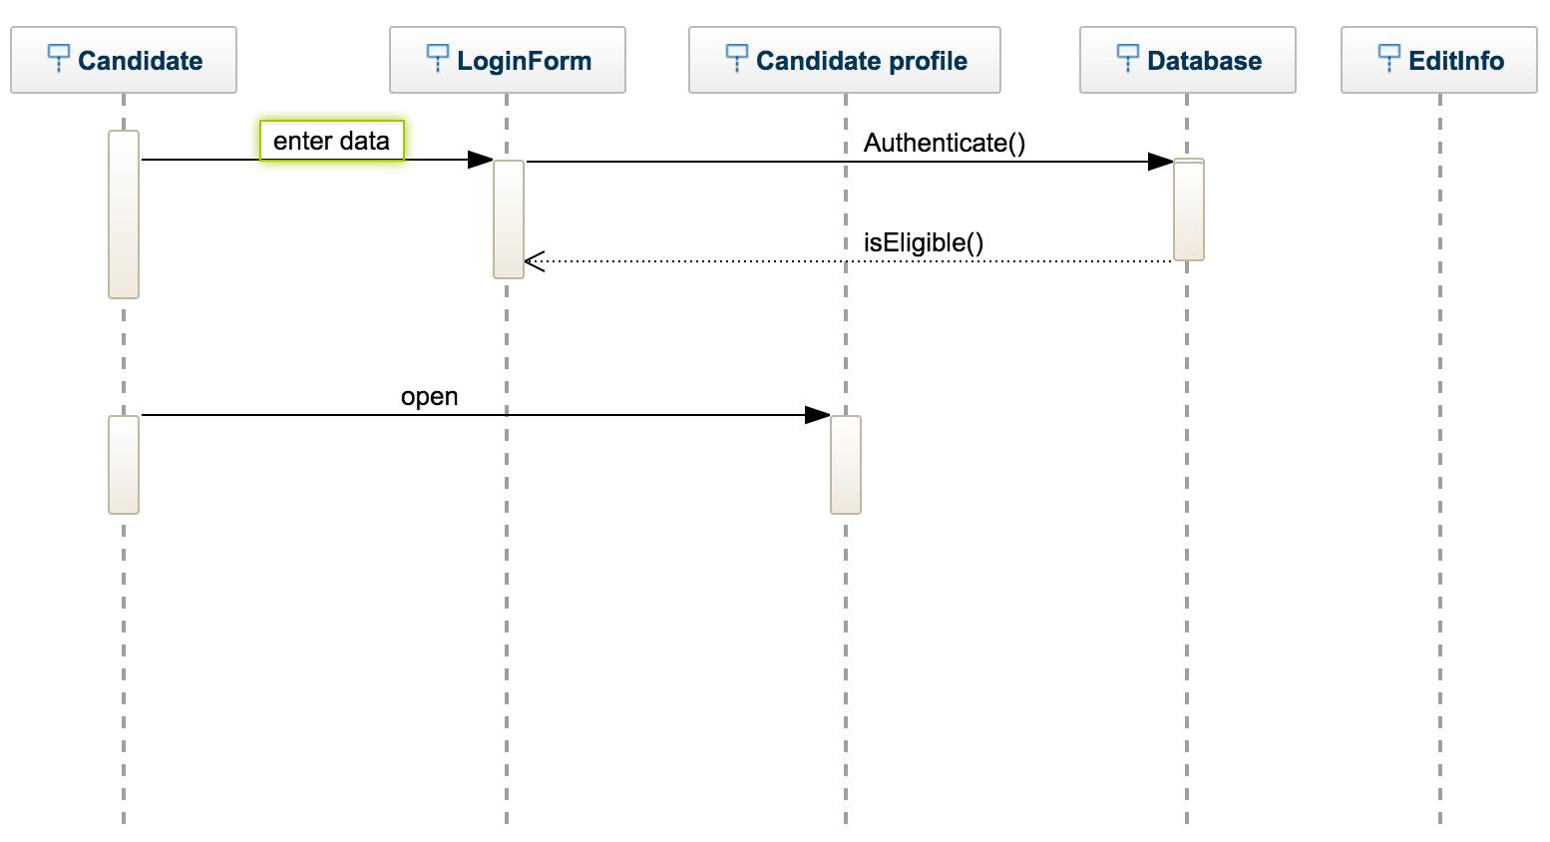

1. **User interface**

**Home form**

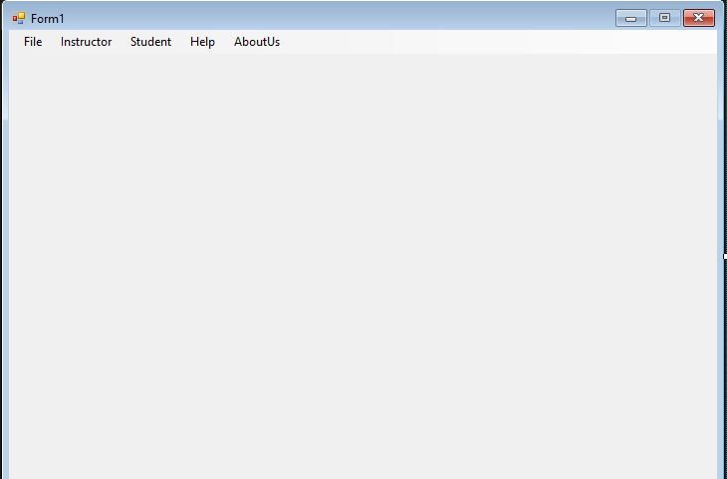

**Login Form**

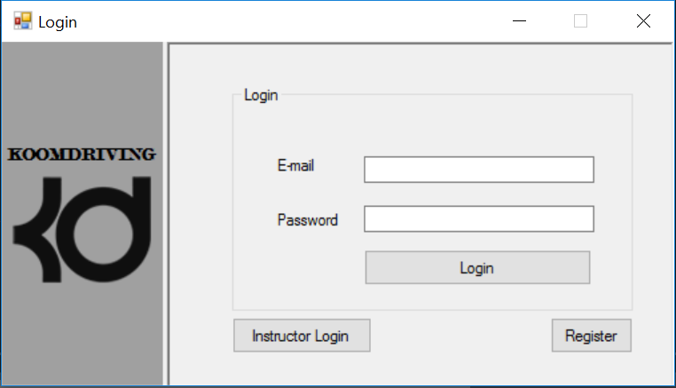

**Candidate Profile form**

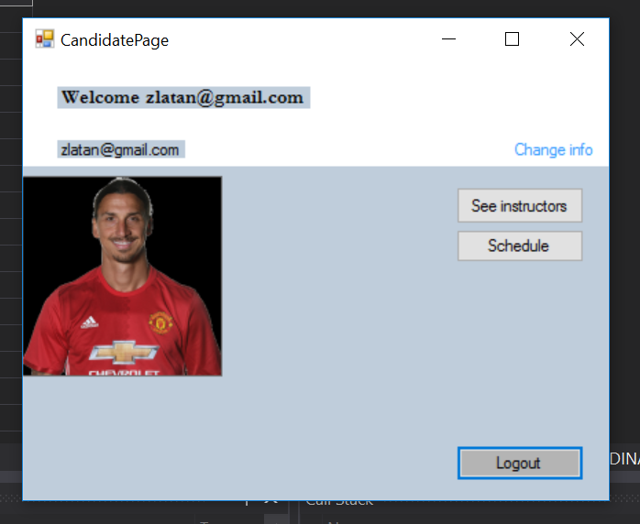

**Edit Candidate profile form**

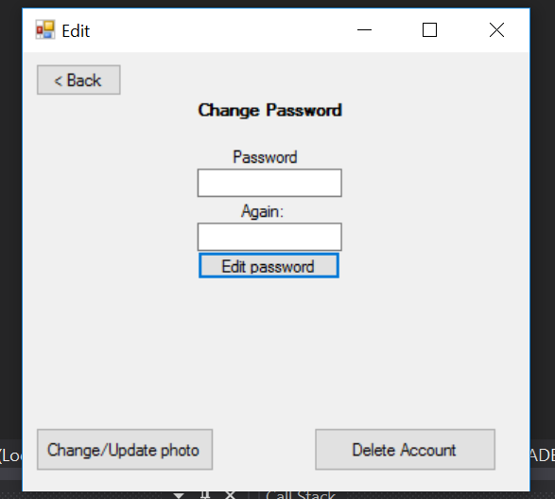

**Instructor login form**

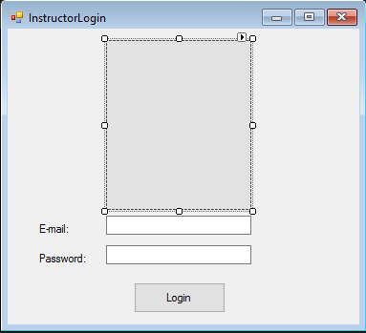

**Contact us form**

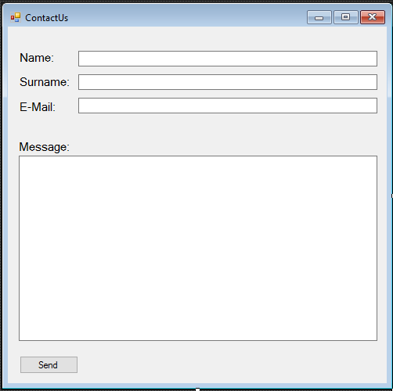

1. **References**

* I Sommerville, Software Engineering*, 9*th ed, Addison-Wesley, 2007.
* *Software Requirements Engineering.* This collection of papers on requirements engineering includes several relevant articles such as 'Recommended Practice for Software Requirements Specification', a discussion of the IEEE standard for requirements documents. (R. H. Thayer and M. Dorfman (eds.), 1997, IEEE Computer Society Press.)    

1. **Extras**

The organization of work for this document is specified in the following table.

|  |  |  |  |  |
| --- | --- | --- | --- | --- |
| **Team member** | **Task** | **Deadline** | **Completed** | **Signature** |
| **Adem Dinarević** | **Class diagram**: for following classes Users, Candidate, Instructor, Candidate profile and Edit database  **Use case**: Candidate Login, Edit candidate profile, upload photo  **Sequence diagram**: Candidate Login  **User interface**: Candidate login, edit profile | 22.3. |  |  |
| **Aziz Boudela** | **Class** **diagram** for following classes: home, register page, instructor login and contact us  **Use case**: Starting application, registering a candidate  **Sequence diagram**: register candidate  **User interface**: home, register page, instructor login and contact us | 22.3. |  |  |
| **Ahmed Aletić** | **Class diagram**: Instructor profile  **Use case**: Instructor Login  **Sequence** **diagram** for: Instructor profile  **User** **interface**: Instructor profile | 22.3 |  |  |